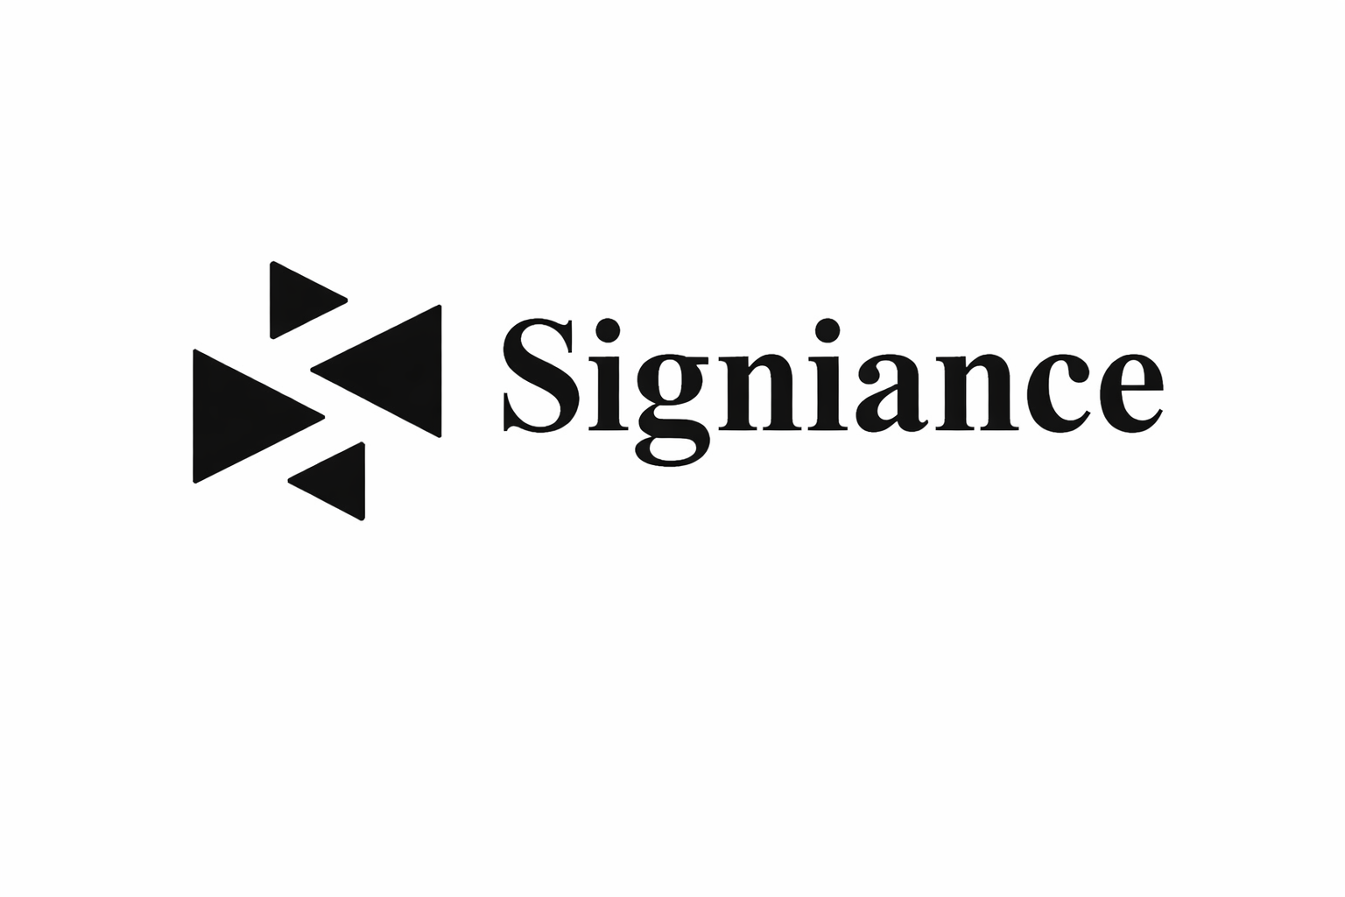

Day 6 Internship Report
AWS Certified Solutions Architect – Udemy Course
(Sections 16–20)

Intern Name: Arsalan Sharief
Company: Signiance Technology
Role: DevOps Intern
Day: 6

Repository Link:
https://github.com/arsalan-signiance/internship-day6

Objective of the Day

The objective of today’s task was to continue learning core AWS services from the AWS Certified Solutions Architect Udemy course, with a specific focus on application decoupling, containers, serverless architecture, and real-world solution design patterns.

Work Completed

Section 17: Decoupling Applications (SQS, SNS, Kinesis)

This section focused on building loosely coupled and scalable architectures using AWS messaging and streaming services.

Amazon SQS (Simple Queue Service)

Learned about Standard Queues and their features such as high throughput and at-least-once message delivery.

Understood SQS Long Polling to reduce empty responses and lower costs.

Studied how SQS integrates with Auto Scaling Groups to automatically scale consumers based on queue depth.

Amazon SNS (Simple Notification Service)

Learned how SNS enables publish-subscribe (pub/sub) messaging.

Understood fan-out architectures where one message is sent to multiple subscribers (SQS, Lambda, email, SMS).

Amazon Kinesis

Studied Kinesis Data Streams for real-time data ingestion and processing.

Learned about Kinesis Data Firehose for loading streaming data directly into services like S3, Redshift, and OpenSearch.

Comparison: SQS vs SNS vs Kinesis

SQS: Message queue for decoupling services.

SNS: Event notification and fan-out.

Kinesis: Real-time data streaming and analytics.

Section 18: Containers on AWS (ECS, EKS, Fargate)

This section introduced containerization and AWS-managed container services.

Docker Introduction

Learned the basics of containers and how Docker packages applications with dependencies.

Amazon ECS (Elastic Container Service)

Understood ECS architecture, task definitions, clusters, and services.

Learned about ECS Auto Scaling for container workloads.

AWS Fargate

Studied serverless container execution without managing EC2 instances.

Amazon ECR (Elastic Container Registry)

Learned how Docker images are securely stored and managed.

Amazon EKS (Elastic Kubernetes Service)

Overview of managed Kubernetes on AWS.

Amazon App Runner

Learned how App Runner simplifies deployment of containerized web applications.

Section 19: Serverless Overview (Solutions Architect Perspective)

This section focused on fully managed, event-driven AWS services.

Serverless Introduction

Understood benefits such as no server management, automatic scaling, and cost efficiency.

AWS Lambda

Learned Lambda fundamentals, execution model, and use cases.

Studied Lambda limits and concurrency handling.

Learned about Lambda@Edge and CloudFront Functions for edge computing.

Understood Lambda inside a VPC for private resource access.

Amazon DynamoDB

Learned about fully managed NoSQL database.

Studied advanced features such as global tables, DAX, and streams.

Amazon API Gateway

Learned how API Gateway exposes REST and HTTP APIs for Lambda and backend services.

Amazon Cognito

Studied user authentication, authorization, and identity federation for applications.

Section 20: Serverless Architecture – Solution Architect Discussions

This section applied serverless concepts to real-world architectures.

Mobile Application (To-Do List)

Designed a serverless backend using Lambda, API Gateway, DynamoDB, and Cognito.

Microservices Architecture

Learned how serverless services enable independent, scalable microservices.

Software Update Distribution

Studied how AWS services like S3, CloudFront, and Lambda can be used for scalable software delivery.

Key Learnings

Importance of decoupling applications for scalability and fault tolerance.

Practical understanding of containers vs serverless architectures.

How AWS managed services reduce operational overhead.

How solution architects design real-world, scalable systems using AWS services.

Note: I have attached the PDF containing the notes and images which were taken during the Udemy lecture.

Prepared by: ArsalanSharief
DevOps Intern – Signiance Technology

